**Greg Brown AP Calculus BC Scores**

**7/25/2019**

**Disclaimer**

AP Calculus students have the option of receiving transferable college credit through UMSL for this class. Every year about 1/3 of the class earns college through USML. The data in this document does not reflect student success through UMSL, it only monitors student success on the AP Calculus exam.

**Official College Board Recommendation Based on AP Exam Score**

A score of 3 is considered a qualifying score, 4 is considered very well qualified, and 5 is considered extremely well qualified.

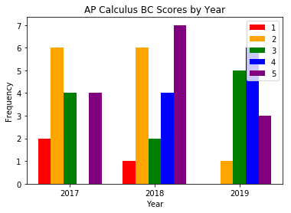

### **AP Calculus BC Scores by Year**

### The graph ghows a few trends. The number of 1s steadily decreased from two in 2017 to zero in 2019. The number of 4s increased from 0 in 2017 to 6 in 2019. Even though 2019 has the smallest number of 1s and 2s, it also has the smallest number of 5s. There were seven 5s in 2018.

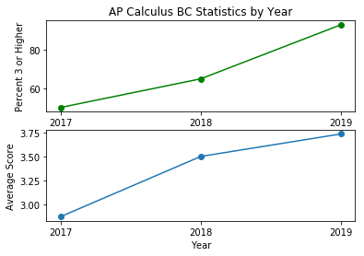

### **AP Calculus BC Statistics by Year**

##### **Percent 3 or Higher**

##### Starting at 50% in 2017, the percent of 3 or higher scores increased to 93% in 2019. The percent of 3 or higher AP Calculus BC scores is increasing at a faster rate.

##### **Average Score**

##### The highest average AP Calculus BC score achieved so far is 3.75 which was achieved in 2019. The average scores of AP Calculus BC are increasing.

# Overall Conclusion for Greg Brown’s AP Calculus BC scores

# AP Calculus BC performance has been steadily increasing to their highest numbers yet in 2019. 93% of students earning a 3 or higher is exceptional.

# Goal for next year

# My goal for AP Calculus BC in 2020 is to have at least seven 5s, 100% 3 or higher, and an average score of at least 4.